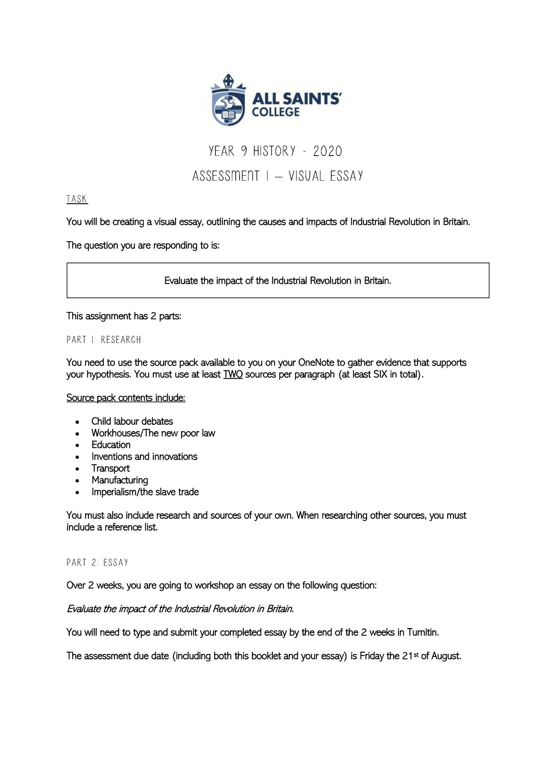

HASS Essay Industrial Revolution (Britain)

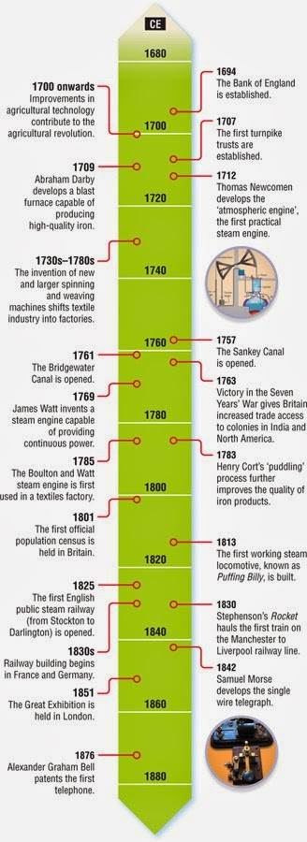

During the time period of 1760-1840 there was a significant change to how the people of Britain lived and worked for that would effect on how we live our lives today and it was called the industrial revolution.

The industrial revolution also known as the first industrial revolution was the transition from an agrarian (farming) and handicraft economy to one dominated by industry and machine manufacturing in Europe, the transition included new chemical manufacturing and iron production processes and the increasing use of steam and water power. The industrial revolution had a massive impact on the type of transport people use in Britain in today’s modern society. The industrial revolution introduced the use of the steam train that was used to transport people around Britain and transport goods like iron and wood around Europe. This included road and rail transport changes as well as shipping and canal transport. Road was by horse drawn or hand carting.

Road transport made a massive impact on the lives of the British people, by bring goods to the towns and villages faster than ever before, it subsequently changed the way people thought because now they had opportunity to leave the village existence and expanded their life away from farming to industry and many move to the towns seeking work and a better life. As evidenced by source 5 “*Freight went via the packhorse, a slow, cumbersome activity which was expensive and low in capacity. Livestock could be moved by herding them while alive, but this was a tiring process. People used the roads to travel, but movement was very slow and only the desperate or the rich travelled much”.* Now transport came within reach of the poor, but new transport needed better roads, because transport relied on and was affected by the quality of the road surface and this subsequently lead to the development of much better road research and road conditions. (Source 1). These improvements included the start of Turnpike where people paid to use the new road, and roads became a matter for all of Britain to deal with rather than the individual town control of earlier times.

*General Wade, Jack Metcalf, Thomas Telford and John Macadam developed better roads, with firm foundations, drainage and a smooth surface.*

**Steam Rail**

When the steam train were first introduce in 1802 it changed the way goods and people were transported across Britain forever, there were several inventors involved and through development and creation a steam train that worked efficiently was evolved. *“The journey from London to the Royal Palace at Balmoral (Scotland) was 45 hours by coach. By train it was only 12 hours.” (source Pack 3 section 1)*

The impact on the people led to a new way of thinking about how they lived and worked and this led to the workhouse philosophy where mass production in industry began particularly in metal working. With the railway the requirement for iron rails (see source 2) led to steel mills and iron works being established and needing lots of cheap labour. We started to see the beginnings of the workhouse.

* There was a 'Railway Mania' in the 1840s. £3 billion was spent building the railways between 1845 and 1900.
* In 1870, 423 million passengers travelled on 16,000 miles of line. (source 2)

Rail did not exist until steam revolutionized the transport medium. (source 3)

***The Development of the Railways***

*In 1767 Richard Reynolds created a set of rails for moving coal at Coalbrookdale; these were initially wood but became iron rails. In 1801 the first Act of Parliament was passed for the creation of a ‘railway’, although at this point it was a horse pulled carts on rails. Small, scattered railway development continued, but at the same time, the steam engine was evolving. In 1801 Trevithic invented a steam driven locomotive which ran on* [*roads*](https://www.thoughtco.com/development-of-roads-the-industrial-revolution-1221647)*, and 1813 William Hedly built Puffing Billy for use in mines, followed a year later by George Stephenson’s engine.*

*In 1821 Stephenson built the Stockton to Darlington railway using iron rails and steam power with the aim of breaking the local monopoly of the canal owners.*

*The first railway was the Stockton and Darlington Railway (1825). George Stephenson built the Rocket (1829). Significant engineering achievements included the London Underground (1863) and the Forth Bridge (1890).*

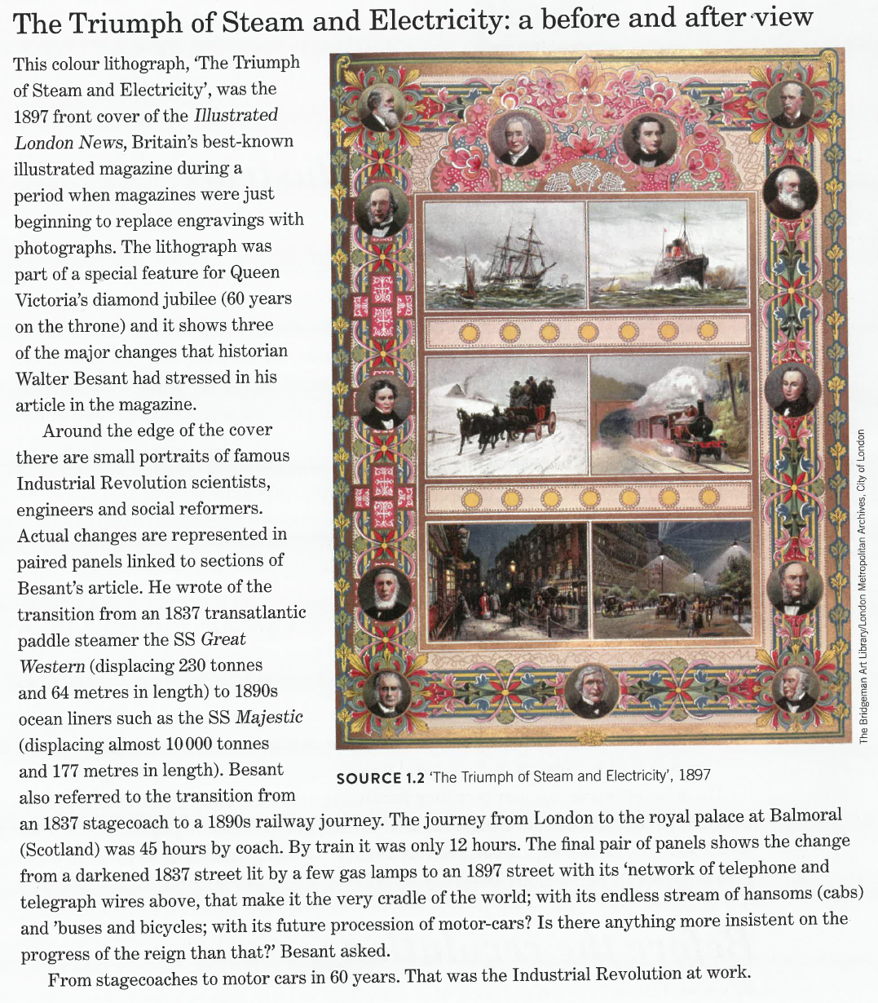

**Steam Boats**

The emergence of steam had an immense impact on sailing ship and canal transport. In particular wooden ships converted to steel and transport on the water increased the time it took to move goods thousands of kilometres. The days of sail and rowing ended with steam. The days of being stuck in the Doldrums ended for sailors as steam changed the ways of the sea as steam took over from sail. Metal hulled tankers and cargo-carrying ships emerged as did cruise ships for travel and the exploration of the world by all people rich and poor alike. It also dramatically changed the fighting capabilities for armies and navies throughout the world. I would suggest that the steam for boats had a bigger impact on the world than the parochial impact of road and rail transport. (Source Pack 3 section 5)

*“The steam engine was evolved in order to best serve the interests of the imperial powers of Europe. While most European imperial powers jumped on board the steam power scheme, it was the British that staged, implemented and perfected the use of steam power in their colonies.”*

Canals had more impact on internal transportation by utilising existing infrastructure because the canal system had been in existence for many years prior to steam, the difference was in speed and expansion of destinations. (Source Pack 3 source 4b).

*“Canals allowed a greater volume of goods to be moved more precisely, and for much less, opening up new markets in terms of location and affordability.”*

The impact of steam alone may well be the biggest thing to change society, because after steam the way the people lived was changed so much that centuries of plodding along in village style was left behind and opportunities to work in factories and industry affected everyone in such a few short years. Not always for the betterment of everyone.

**Isaac Faulks**

**References**

Industrial Revolution

Source 1

<https://firstindustrialrevolution.weebly.com/transportation-revolution.html>

Source 2

Britain Roads

<https://www.bbc.co.uk/bitesize/guides/zvmv4wx/revision/8>

Source 3

https://www.thoughtco.com/railways-in-the-industrial-revolution

**Source Pack 3 Transport Revolution**

**SOURCE 1: *Extract of ‘The Triumph of Steam and Electricity 1987’***

*The Bridgeman Art Library London Metropolitan Archives City of London*

*Nelson Modern History: The Industrial Revolution by Tony Taylor*

**SOURCE 2***The State of the British Roads pre-1700*

The British road network hadn’t experienced many major additions since the Romans had built some over a millennia and a half earlier. The main roads were largely the decayed remains of the Roman system, with little attempt at improvements until after 1750. Queen Mary Tudor had passed a law-making parishes responsible for roads, and each was expected to use labour, which workers were obliged to offer, for free six days a year; landowners were expected to offer the materials and equipment. Unfortunately, the workers were not specialised and often didn’t know what to do when they got there, and with no pay there wasn’t much incentive to really try. The result was a poor network with much regional variation.

Despite the appalling conditions of the roads, they were still in use and vital in areas not near a major river or port. Freight went via the packhorse, a slow, cumbersome activity which was expensive and low in capacity. Livestock could be moved by herding them while alive, but this was a tiring process. People used the roads to travel, but movement was very slow and only the desperate or the rich travelled much. The road system encouraged parochialism in Britain, with few people – and thus few ideas – and few products travelling widely.

*The Turnpike Trusts*

The one bright spot among the British road system were the Turnpike Trusts. These organisations took care of gated sections of road, and charged a toll on everybody travelling along them, to be ploughed into upkeep. The first turnpike was created in 1663 on the A1, although it was not run by a trust, and the idea didn’t catch on until the start of the eighteenth century. The first actual trust was created by Parliament in 1703, and a small number were created each year until 1750. Between 1750 and 1772, with the needs of industrialization pressing, this much higher.

Most turnpikes improved the speed and quality of travel, but they increased the cost as you now had to pay. While the government spent time arguing over wheel sizes (see below), the turnpikes targeted the root cause of the problem in the shape of road conditions. Their work on improving conditions also produced road specialists who worked on larger solutions which could then be copied. There were criticisms of turnpikes, from a few bad trusts who simply kept all the money, to the fact that only around a fifth of the British road network was covered, and then only the major roads. Local traffic, the main type, benefited much less. In some areas parish roads were actually in better conditions and cheaper. Even so, the expansion of Turnpikes caused a major expansion in wheeled transport.

*Roads Legislation after 1750*

With a growing understanding of Britain’s industrial expansion and population growth, the government passed laws aimed at preventing the road system decaying any further, rather than improving the situation. The Broadwheel Act of 1753 widened the wheels on vehicles to reduce damage, and the General Highway Act of 1767 made adjustments to the wheel size and number of horses per carriage. In 1776 a law provided for parishes to employ men specifically to repair roads.

*The Results of Improved Roads*

With the quality of roads improving – albeit slowly and inconsistently – a greater volume could be moved faster, especially expensive items which would absorb the turnpike bills. By 1800 stage coaches became so frequent that they had their own timetables, and the vehicles themselves were improved with better suspension. British parochialism was broken down and communications improved. For instance, the Royal Mail was set up in 1784, and their coaches took post and passengers across the country.

While industry did rely on roads at the start of its revolution, they played a far smaller role in moving freight than the newly emerging transport systems, and it is arguably roads’ weaknesses which stimulated the building of canals and railways. However, where historians once identified a decline in roads as new transport emerged, this is largely rejected now, with the understanding that roads were vital for local networks and the movement of goods and people once they had come off the canals or railways, whereas the latter were more important nationally.

[*https://www.thoughtco.com/development-of-roads-the-industrial-revolution-1221647*](https://www.thoughtco.com/development-of-roads-the-industrial-revolution-1221647)

**SOURCE 2a: *A Map of the density of the turnpike road network in 1770***

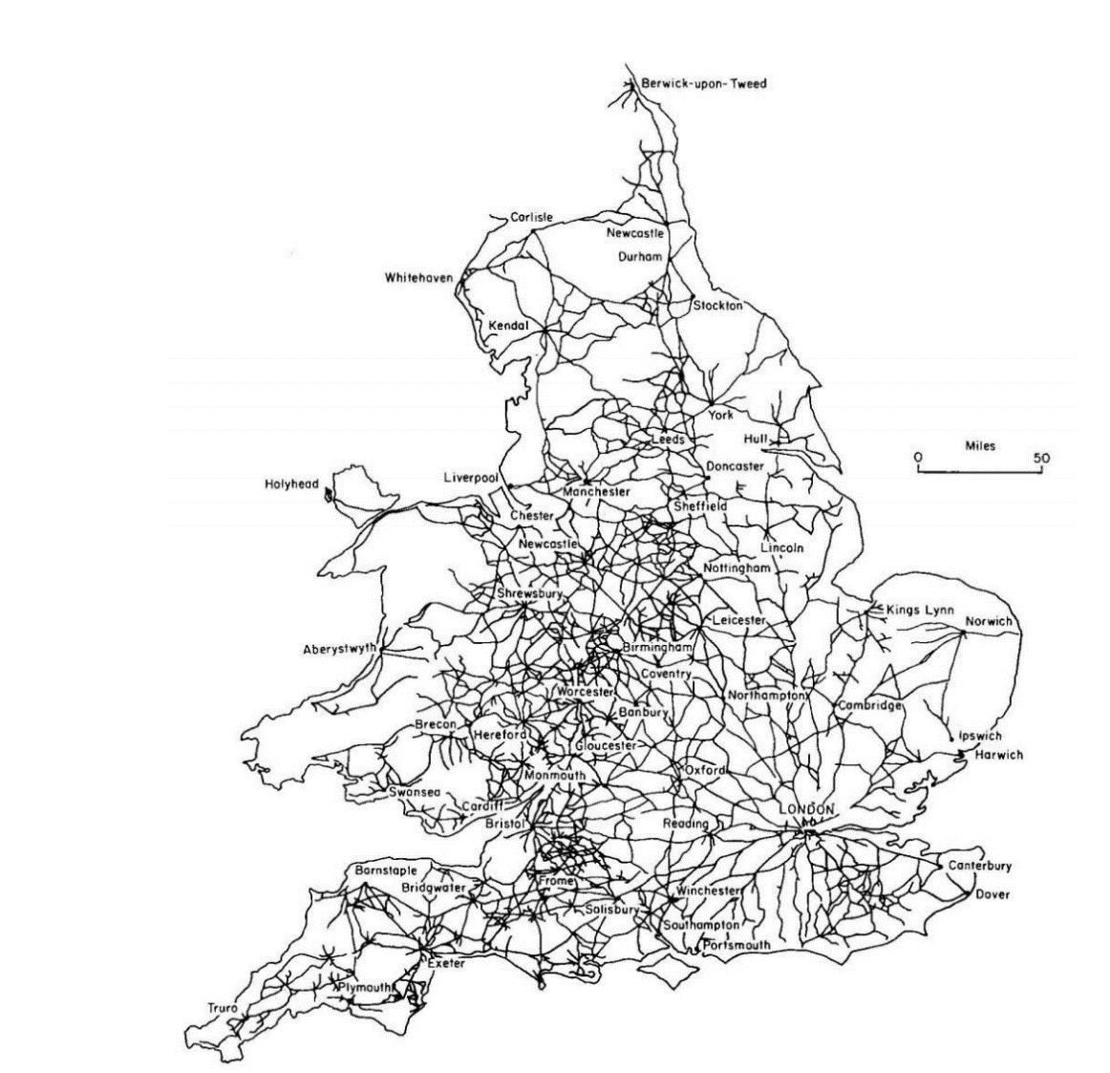

*Pawson’s (1977: 51) map represented in* [*http://www.socsci.uci.edu/~dbogart/transport_revolution_surveyjan2013.pdf*](http://www.socsci.uci.edu/~dbogart/transport_revolution_surveyjan2013.pdf)

**SOURCE 3**

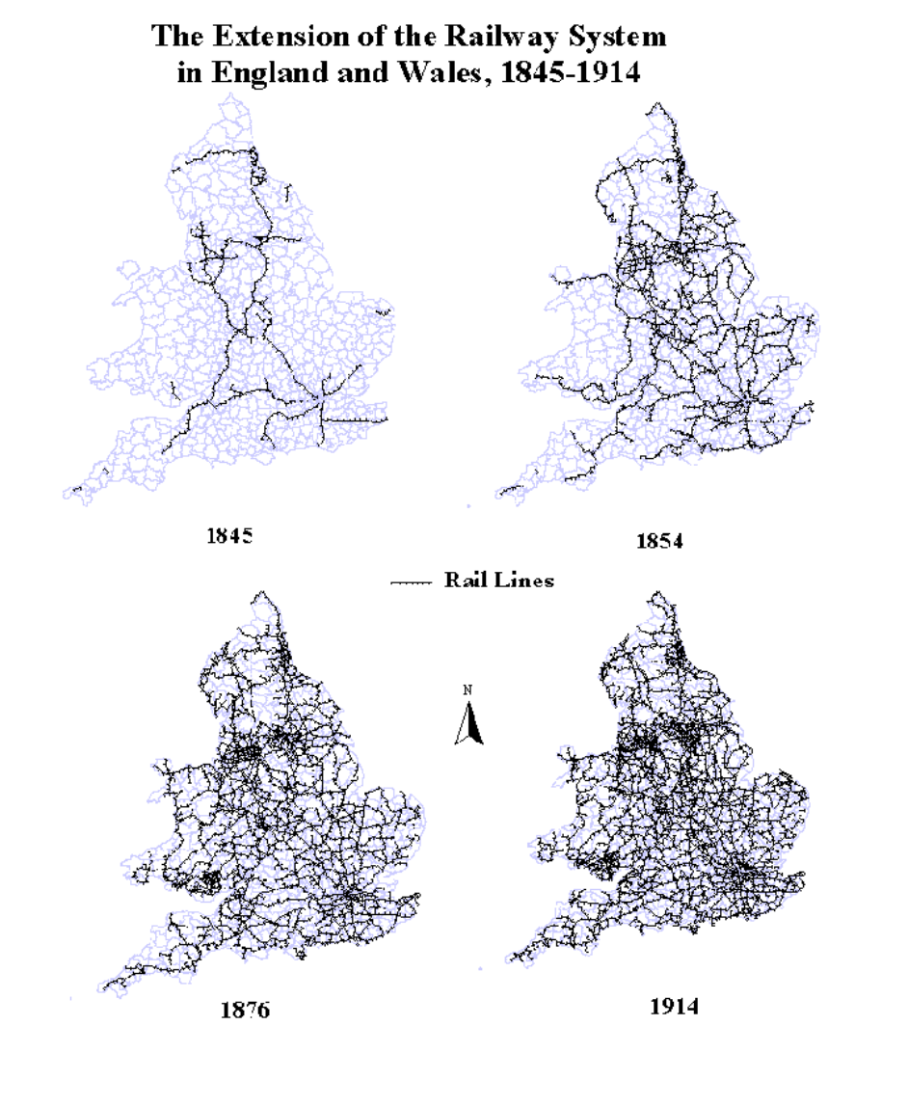***Map of the extension of the railway system in England and Wales, 1845–1914*.**

*Robert Schwartz Mt.Holyoke College* [*https://www.mtholyoke.edu/courses/rschwart/rail/intro_hist_gis.htm*](https://www.mtholyoke.edu/courses/rschwart/rail/intro_hist_gis.htm)

**SOURCE 3a: *Key points of the Railway Regulation Act 1844***

The Act required that one train with provision for carrying third-class passengers, should run on every line, every day, in each direction, stopping at every station. (These are what were originally known as "Parliamentary Trains." And we often at late at night or early in the morning to discourage second class passengers from changing class.

1. The fare should be 1d.(denarius) 1/240 of a pound Sterling per mile (1.6km)
2. Its average speed should not be less than 12 miles per hour (19 km/h).
3. Third-class passengers should be protected from the weather and be provided with seats.
4. carry 56 lb (25 kg) of luggage free

[*http://www.railwaysarchive.co.uk/docsummary.php?docID=58*](http://www.railwaysarchive.co.uk/docsummary.php?docID=58)

**SOURCE 3b: *Extract of The Impact of Railways on Victorian Cities***

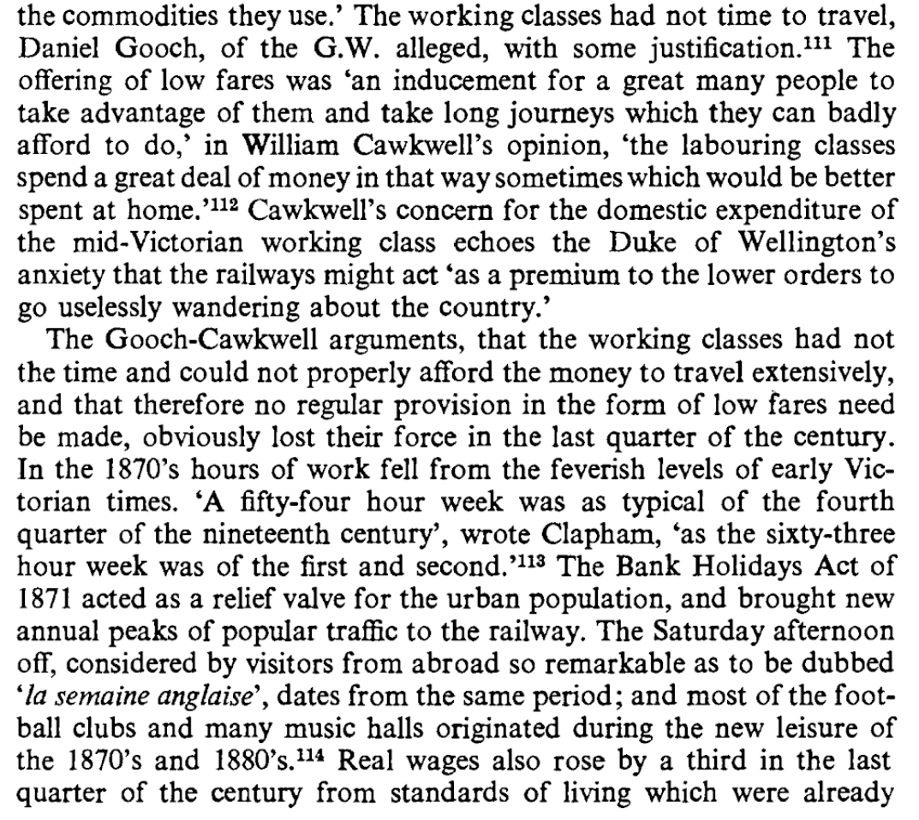The extract discusses the opposition to a proposal to improve ‘third-class’ travel as proposed in the Railway Regulation Act, 1844.

.

*

* ‘The English Week’ *The Impact of Railways on Victorian Cities by John R. Kellett.*

**SOURCE 3c ROAD V RAIL**

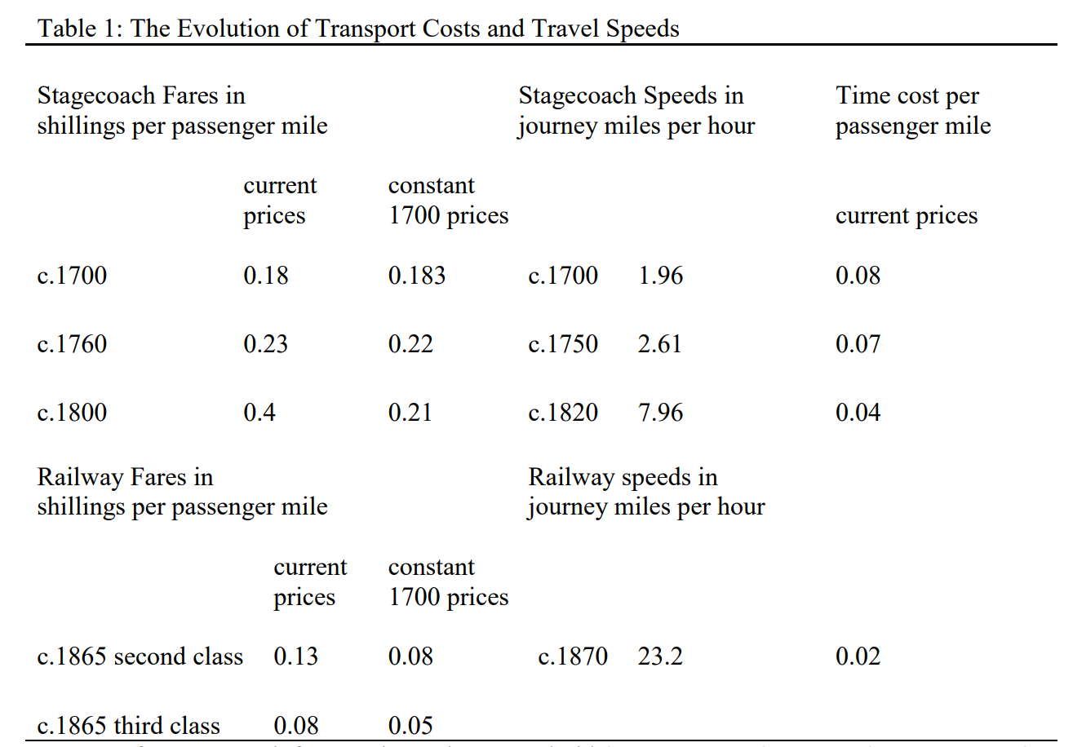***The Evolution of Transport Costs and Travel Speeds***

**Source 3d ROAD V WATER V RAIL FREIGHT**

***The Evolution of Freight Cost***

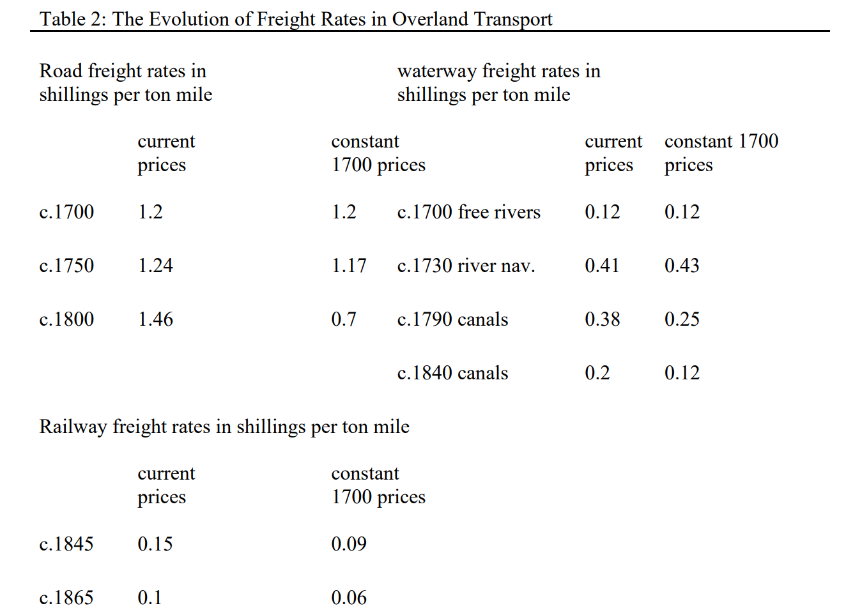

[*http://www.socsci.uci.edu/~dbogart/transport_revolution_surveyjan2013.pdf*](http://www.socsci.uci.edu/~dbogart/transport_revolution_surveyjan2013.pdf)

**SOURCE 4: WATERWAYS**

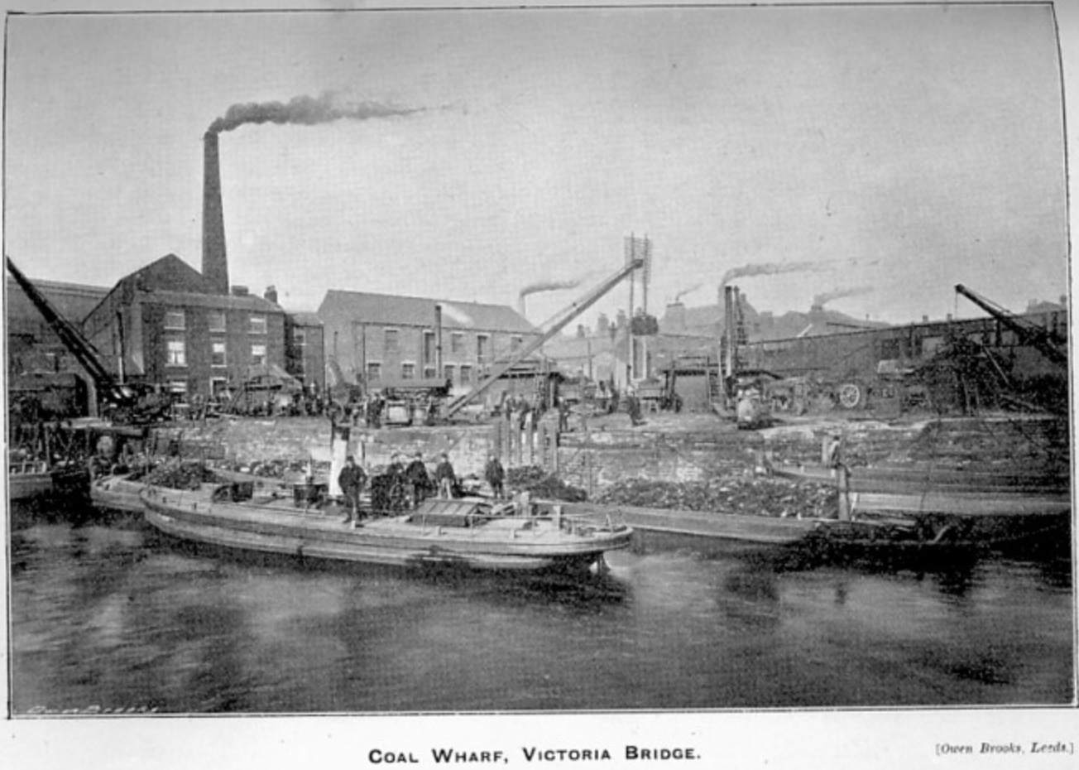**The Canals**

*Circa 1890*

[*http://www.aireboroughcivicsociety.org.uk/the-history-of-canals-in-britain*](http://www.aireboroughcivicsociety.org.uk/the-history-of-canals-in-britain)

**SOURCE 4b: WATERWAYS   
*The Economic Impact of Canals -*** [*https://www.thoughtco.com/development-of-canals-the-industrial-revolution-1221646*](https://www.thoughtco.com/development-of-canals-the-industrial-revolution-1221646)

Canals allowed a greater volume of goods to be moved more precisely, and for much less, opening up new markets in terms of location and affordability. Seaports could now be connected to inland trade. Canals allowed for the greater exploitation of coal reserves as the coal could be moved further, and sold cheaper, allowing a new market to form. Industries could now relocate to coalfields or move to towns, and the materials and products could be moved either way. Of over 150 canal acts from 1760 to 1800, 90 were for coal purposes. At the time—before the railways—only canals could have coped with the swiftly rising demand for coal from industries like iron. Perhaps the most visible economic effect of canals was around Birmingham, which was now joined to the British freight transport system and grew hugely as a result.

Canals stimulated new ways of raising capital, as the majority of canals were built as joint stock companies, with each company having to apply for an act of Parliament. Once created, they could sell shares and buy land, bringing in widespread investment, not just local. Only a tenth of the funding came from the elite of wealthy industrialists, and the first modern company management structures were put in place. Capital began to flow around the constructions. Civil engineering also advanced, and this would be fully exploited by the railways.

**SOURCE 5: SHIPS**

***Extract discussing imperialism and the steam ship***

Following in the wake of the steam-train was the steamship, arguably the most important invention for exploration, imperial gain and colonial governance. As Headrick notes, the British had held control over the seas for centuries, yet their control on water was limited to the wide open expanses of oceans and seas, and European domination of the seas faded away at the shoreline (1979). The steamship was the answer to this problem as it was powerful enough and small enough to traverse rivers and streams. The steamship allowed trade to boom, and imports from Britain’s colonies graced British shores in larger numbers and in quicker turn-around times than ever before. Puffing upstream and downstream, the British steamer aided communication, strengthened political ties and governance of colonies. In India, the steam-powered gunboat proved its worth in the dominance of the region and the effectiveness with which it could supress an enemy or internal uprising. In Africa, while problems with disease continued to plague British exploration of the interior, the steamship allowed traders and merchants to cut out the middle man by bypassing the coastal ports and travelling directly to the source of the goods. The steamship, from its beginnings as timber steam-paddle ships to the iron steamers and the gunboats of the turn of the century, became the global symbol of British power and dominance.

The steam engine was evolved in order to best serve the interests of the imperial powers of Europe. While most European imperial powers jumped on board the steam power scheme, it was the British that staged, implemented and perfected the use of steam power in their colonies. For the British, the progress of steam technology never slowed or faltered. It powered steadily on towards the future, full steam ahead.

[*https://makinghistoryatmacquarie.wordpress.com/2013/11/17/full-steam-ahead-british-empire-and-industry/*](https://makinghistoryatmacquarie.wordpress.com/2013/11/17/full-steam-ahead-british-empire-and-industry/)

**SOURCE 5a: SHIPS**

https://www.express.co.uk/news/science/749712/titanic-fire-theory-channel-4-titanic-documentary***The British liner the Titanic leaves Southampton, England, at the start of its doomed voyage on April 10, 1912.***

[*https://www.history101.com/discovered-photo-album-reveals-the-real-reason-why-the-titanic-sank/*](https://www.history101.com/discovered-photo-album-reveals-the-real-reason-why-the-titanic-sank/)